**Group 2**

**MotorPH GUI Application**

**Members:**

**Charles Ferdiemar Gan**

**Dioscoro Bondoy**

**Marc Darell Guevarra**

**Waleed El - Shair**

**Login window**

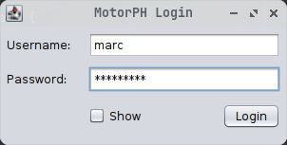

**Main window**

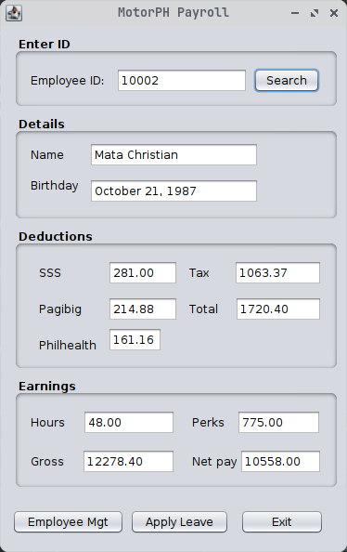

**Leave application window**

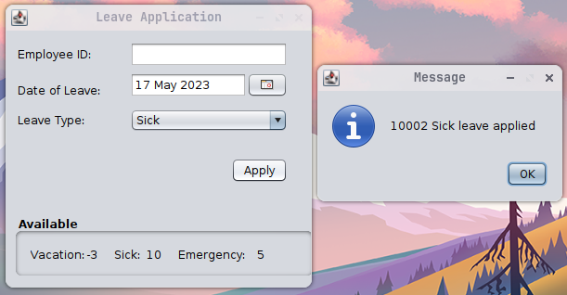

**Employee management window**